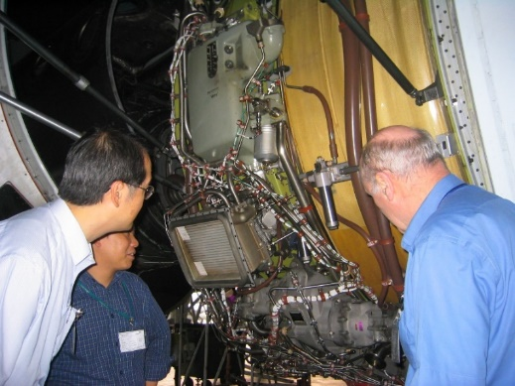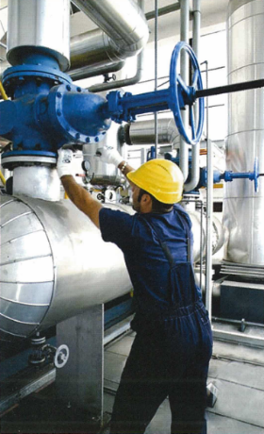HKSQ Workshop

**on**

Reliability & Maintenance Analyses

**18 November – 16 December 2017**

(Deadline for registration: 13 November 2017)

# **Registration Form**

|  |  |  |  |
| --- | --- | --- | --- |
|  |  | (in Chinese) |  |

*\* Delete whichever is inappropriate*

Correspondence Address:

|  |
| --- |
|  |

|  |  |  |  |  |
| --- | --- | --- | --- | --- |
|  |  |  |  |  |
| (Private E-mail) |  | (Telephone) |  | (Fax) |

|  |  |
| --- | --- |
| Company Name: |  |
| Position: |  |
| Department: |  |

Company Address:

|  |
| --- |
|  |

|  |  |  |  |  |
| --- | --- | --- | --- | --- |
|  |  |  |  |  |
| (Office E-mail) |  | (Telephone) |  | (Fax) |

Please ⌧ whatever appropriate

Self-financed  Company Sponsored

|  |  |
| --- | --- |
| HKSQ member  ASQ member  Membership No: |  |

TQM Client  Others

|  |  |  |
| --- | --- | --- |
| A cheque payable to “The Hong Kong Society for Quality Ltd.” for the amount of | | |
| HK$ |  | is enclosed. (The registration fee per participant is HK$ 5,300 for HKSQ / |
| ASQ members, and clients of TQM Consultants Co., Ltd., HK$ 5,600 for others.) | | |

|  |  |  |  |  |
| --- | --- | --- | --- | --- |
| Signature: |  |  | Date: | (dd/mm/yyyy) |

Please send completed registration form with payment to: Dr. Albert Tsang, c/o Department of Industrial and Systems Engineering, The Hong Kong Polytechnic University, Hung Hom, Kowloon.

For enquiries, send email to [albert.tsang@polyu.edu.hk](mailto:albert.tsang@polyu.edu.hk) or [cpchow46@gmail.com](mailto:cpchow46@gmail.com)