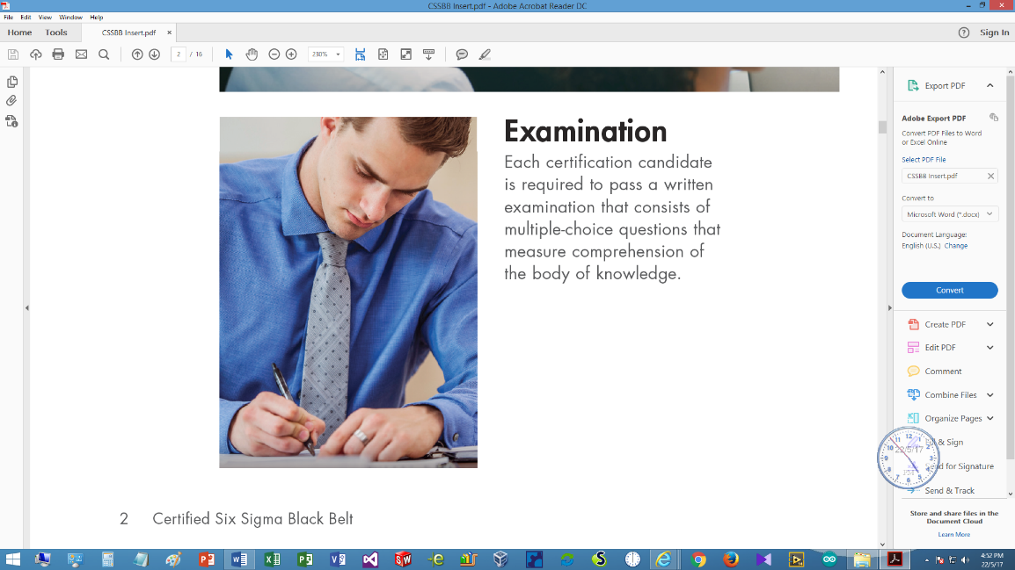HKSQ Workshop

on

Body of Knowledge for

Six Sigma Black Belt

15 September – 3 November 2018

# Registration Form

(Deadline for registration: 11 September 2018)

|  |  |  |  |
| --- | --- | --- | --- |
|  |  | (in Chinese) |  |

*\* Delete whichever is inappropriate*

Correspondence Address:

|  |  |  |  |  |
| --- | --- | --- | --- | --- |
|  | | | | |
|  |  |  |  |  |
| (Private E-mail) |  | (Telephone) |  | (Fax) |

|  |  |
| --- | --- |
| Company Name: |  |
| Position: |  |
| Department: |  |

Company Address:

|  |  |  |  |  |
| --- | --- | --- | --- | --- |
|  | | | | |
|  |  |  |  |  |
| (Office E-mail) |  | (Telephone) |  | (Fax) |

Please ⌧ whatever appropriate

Self-financed  Company Sponsored

|  |  |
| --- | --- |
| HKSQ member  ASQ member  Membership No: |  |

TQM Client  Others

|  |  |  |
| --- | --- | --- |
| A cheque payable to “The Hong Kong Society for Quality Ltd.” for the amount of | | |
| HK$ |  | is enclosed. (The registration fee per participant is HK$ 6,000 for members |
| of HKSQ / ASQ, or clients of TQM Consultants Co., Ltd., HK$ 6,300 for others.) | | |

|  |  |  |  |  |
| --- | --- | --- | --- | --- |
| Signature: |  |  | Date: | (dd/mm/yyyy) |

Please send completed registration form with payment to: Dr. Albert Tsang, Hong Kong Society for Quality, P.O. Box 84375, Hunghom Bay Post Office, Hung Hom, Kowloon, Hong Kong.

For enquiries, contact Dr. Albert Tsang at 9182 7810 by phone, or send email to [dr.albert.tsang@gmail.com](mailto:dr.albert.tsang@gmail.com) or [info@hksq.org](mailto:info@hksq.org)